|  |
| --- |
|  |
| Capstone Project Document |

**Outsourcing Human Resource Management**

Report #2 – Screen Design

|  |  |  |
| --- | --- | --- |
| **Dandelion** | | |
| **Group Members** | Nguyễn Hữu Phước | SE61138 |
| Nguyễn Thị Xuân Mai | SE60910 |
| Ngô Trắc Kiện | SE61016 |
| Trần Quốc Hiệp | SE60928 |
| Đỗ Thanh Dương | SE61191 |
| **Supervisor** | Mr. Nguyễn Văn Sang | |
| **Project code** | OHRM | |

**- Hanoi, 01/2016-**

# SIGNATURE PAGE

AUTHOR: Nguyễn Thị Xuân Mai 17/02/2016

Team member

REVIEWERS: Nguyễn Hữu Phước //2016

Project manager

APPROVAL: Nguyễn Văn Sang --/--/--16

Supervisor

Record of change

*A - Added M - Modified D – Deleted

|  |  |  |  |  |  |
| --- | --- | --- | --- | --- | --- |
| Effective Date | Changed Item | A,M,D | Change Description | Reason for Change | Rev. Number |
| 17/Jan/2016 | Create Screen Design | A | First version | Create Screen Design | 1.0 |
|  |  |  |  |  |  |
|  |  |  |  |  |  |
|  |  |  |  |  |  |
|  |  |  |  |  |  |
|  |  |  |  |  |  |
|  |  |  |  |  |  |
|  |  |  |  |  |  |
|  |  |  |  |  |  |
|  |  |  |  |  |  |
|  |  |  |  |  |  |
|  |  |  |  |  |  |
|  |  |  |  |  |  |
|  |  |  |  |  |  |
|  |  |  |  |  |  |
|  |  |  |  |  |  |
|  |  |  |  |  |  |
|  |  |  |  |  |  |
|  |  |  |  |  |  |
|  |  |  |  |  |  |
|  |  |  |  |  |  |
|  |  |  |  |  |  |
|  |  |  |  |  |  |
|  |  |  |  |  |  |

Table of Contents

SIGNATURE PAGE 1

Introduction 3

1.1 Purpose 3

1.2 Definitions, Acronyms and Abbreviations 3

1.3 Overview 3

2 Screen flow 4

2.1 Login 4

2.2 Project 5

2.3 Recruitment 6

2.4 Report 7

# Introduction

## Purpose

To ensure consistency and simplicity in detailed design across all displays within a product interface, as well as across other products used by the same users. Definitions, acronyms, abbreviations, references and overview of OHRM website.

## Definitions, Acronyms and Abbreviations

|  |  |  |
| --- | --- | --- |
| Abbreviations | Description | Comment |
| OHRM | Outsourcing Human Resource Management |  |
| Q&A | Question and Answer |  |

1. Definitions, Acronyms and Abbreviations

## Overview

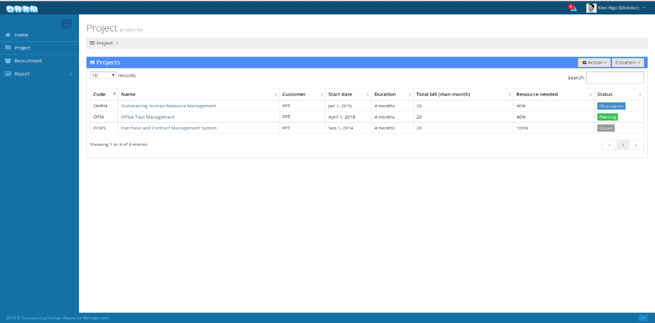

# Screen flow

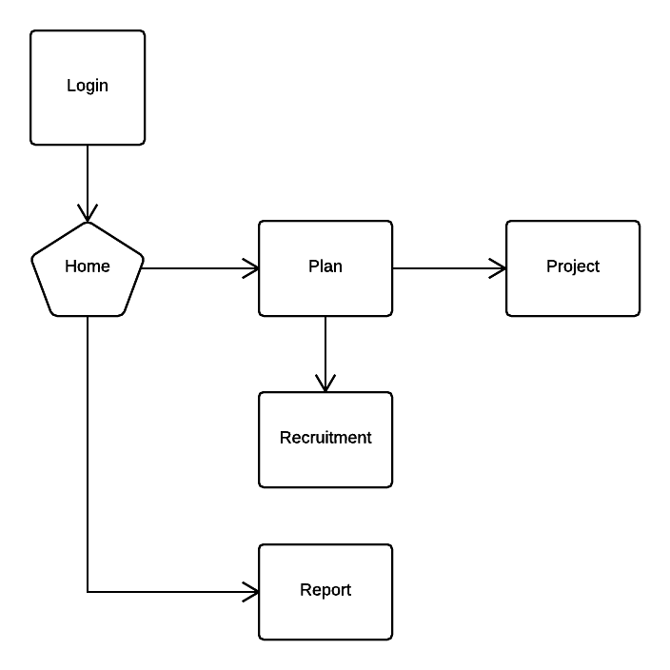

1. Client screen flow

## Login

1. Login **screen**

|  |  |  |  |  |  |  |  |
| --- | --- | --- | --- | --- | --- | --- | --- |
| No | Field name | Field name in Vietnamese | Type | Require | Mandatory | Max-Length | Description |
|  |  |  |  |  |  |  |  |
|  |  |  |  |  |  |  |  |
|  |  |  |  |  |  |  |  |
|  |  |  |  |  |  |  |  |
|  |  |  |  |  |  |  |  |
|  |  |  |  |  |  |  |  |
|  |  |  |  |  |  |  |  |
|  |  |  |  |  |  |  |  |
|  |  |  |  |  |  |  |  |

1. Loginscreen

## Project

### Create project

1. Create project

|  |  |  |  |  |  |  |  |
| --- | --- | --- | --- | --- | --- | --- | --- |
| No | Field name | Field name in Vietnamese | Type | Require | Mandatory | Max-Length | Description |
| 1 | Code | Mã | Text |  | Y |  | Project’s Code |
| 2 | Name | Tên | Text |  | Y |  | Project’s Name |
| 3 | Customer | Khách hang | Text |  | Y |  | Project’s Customer |
| 4 | Start date | Ngày bắt đầu | Text |  | Y |  | Project’s Start date |
| 5 | Duration | Thời gian | Text |  | Y |  | Project’s Duration |
| 6 | Status | Trạng thái | Text |  | Y |  | Project’s Status |
| 7 | Total bill | Tổng bill | Text |  | Y |  | Project’s Total bill |
| 8 | Programming language | Ngôn ngữ lập trình | Text |  | Y |  | Project’s Programming language |
| 9 | Save | Lưu | Button |  | Y |  | Save project |
| 10 | Cancel | Hủy |  |  | Y |  | Cancel project |

1. Create project

### Search project

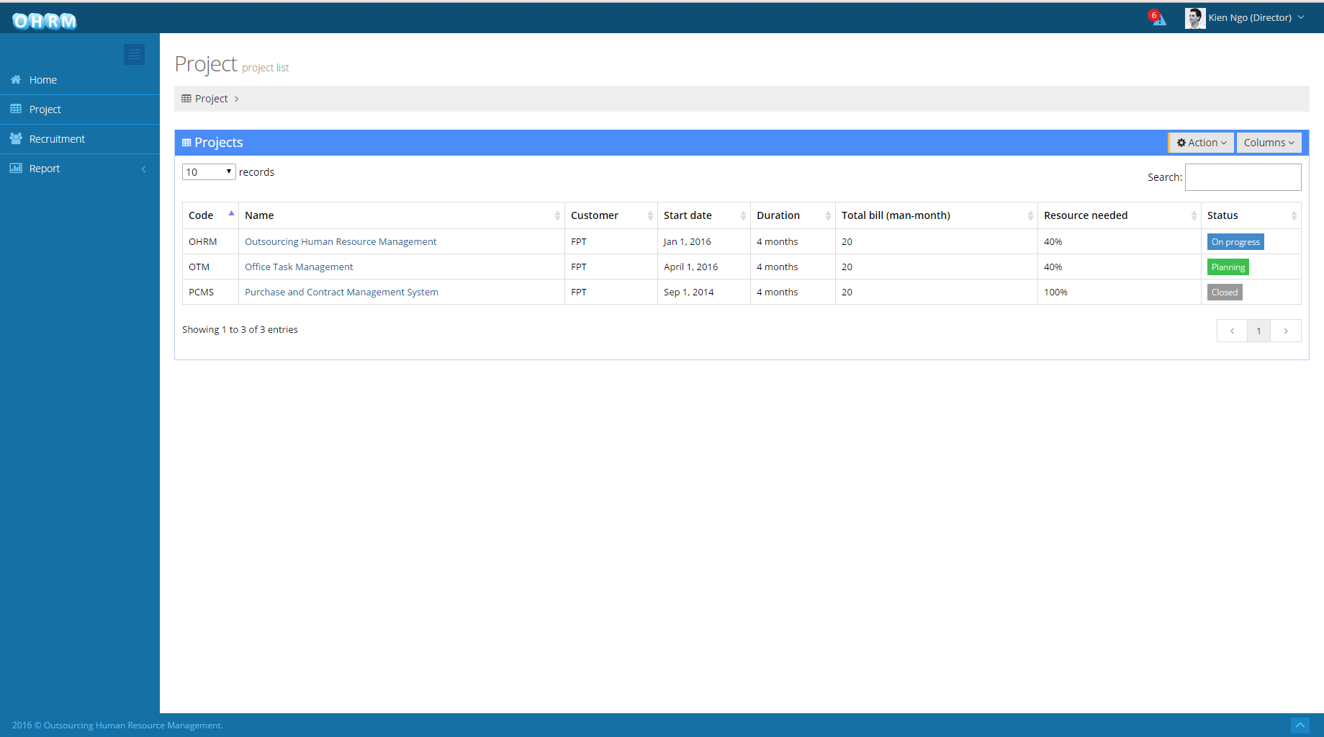

1. Search project

|  |  |  |  |  |  |  |  |
| --- | --- | --- | --- | --- | --- | --- | --- |
| No | Field name | Field name in Vietnamese | Type | Require | Mandatory | Max-Length | Description |
| 1 | Search | Tiềm kiếm | Text |  | Y |  | Search project name |

1. Search project

### View project detail

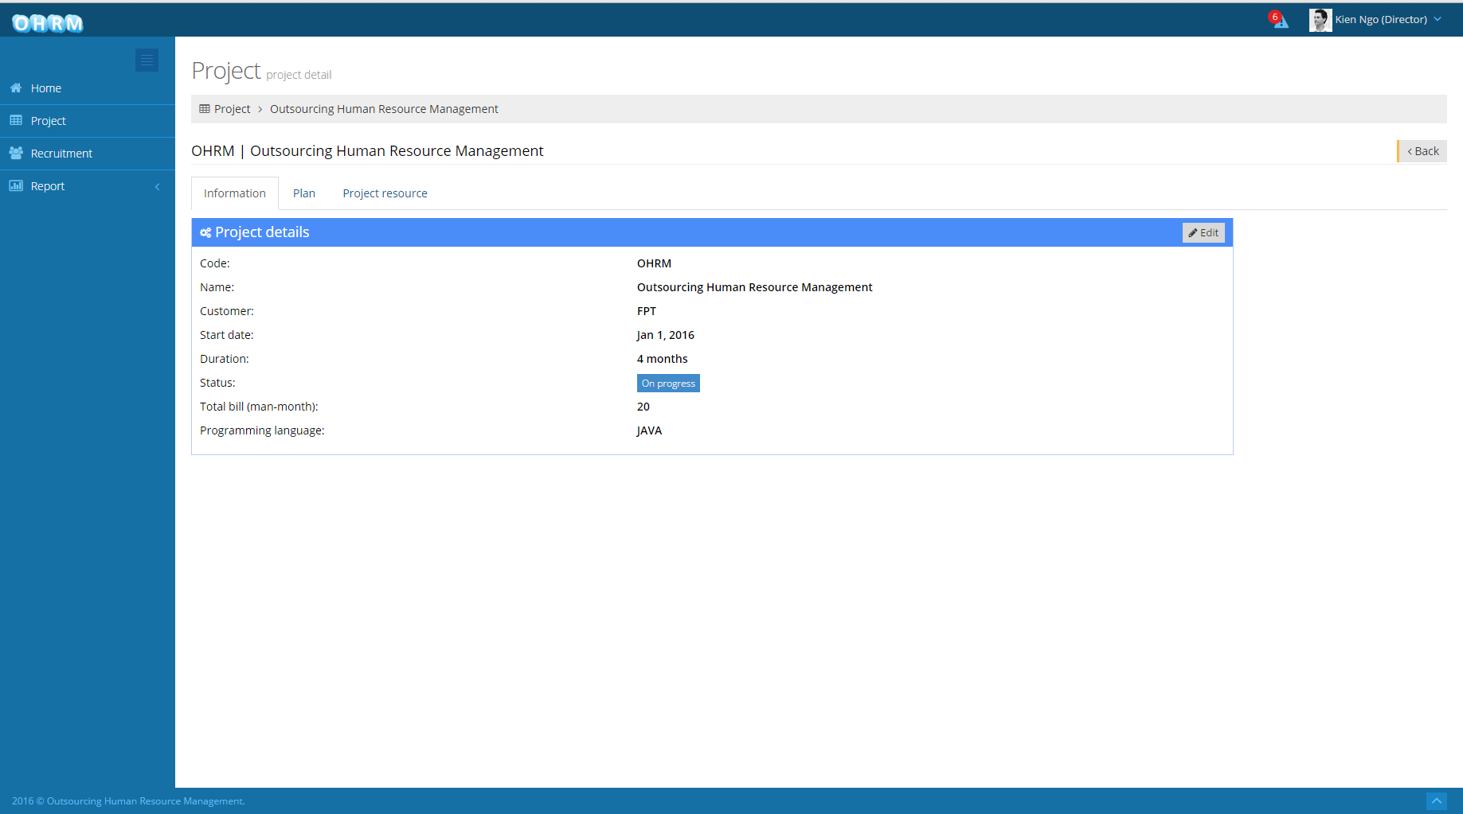

1. View project detail

|  |  |  |  |  |  |  |  |
| --- | --- | --- | --- | --- | --- | --- | --- |
| No | Field name | Field name in Vietnamese | Type | Require | Mandatory | Max-Length | Description |
| 1 | Code | Mã | Label |  | Y |  | Project’s Code |
| 2 | Name | Tên | Label |  | Y |  | Project’s Name |
| 3 | Customer | Khách hang | Label |  | Y |  | Project’s Customer |
| 4 | Start date | Ngày bắt đầu | Label |  | Y |  | Project’s Start date |
| 5 | Duration | Thời gian | Label |  | Y |  | Project’s Duration |
| 6 | Status | Trạng thái | Label |  | Y |  | Project’s Status |
| 7 | Total bill | Tổng bill | Label |  | Y |  | Project’s Total bill |
| 8 | Programming language | Ngôn ngữ lập trình | Label |  | Y |  | Project’s Programming language |
| 9 | Plan | Kế hoạch | Tab |  | Y |  | Plan tab |
| 10 | Project resource | Nhân lực cho dự án | Tab |  | Y |  | Project resource tab |
| 11 | Edit | Chỉnh sửa | Button |  | Y |  | Edit project |
| 12 | Back | Quay lại | Button |  |  |  | Back to previous page |

1. View project detail

### Edit project detail



1. Edit project detail

|  |  |  |  |  |  |  |  |
| --- | --- | --- | --- | --- | --- | --- | --- |
| No | Field name | Field name in Vietnamese | Type | Require | Mandatory | Max-Length | Description |
| 1 | Code | Mã | Text |  | Y |  | Project’s Code |
| 2 | Name | Tên | Text |  | Y |  | Project’s Name |
| 3 | Customer | Khách hang | Text |  | Y |  | Project’s Customer |
| 4 | Start date | Ngày bắt đầu | Text |  | Y |  | Project’s Start date |
| 5 | Duration | Thời gian | Text |  | Y |  | Project’s Duration |
| 6 | Status | Trạng thái | Text |  | Y |  | Project’s Status |
| 7 | Total bill | Tổng bill | Text |  | Y |  | Project’s Total bill |
| 8 | Programming language | Ngôn ngữ lập trình | Text |  | Y |  | Project’s Programming language |
| 9 | Plan | Kế hoạch | Tab |  | Y |  | Plan tab |
| 10 | Project resource | Nhân lực cho dự án | Tab |  | Y |  | Project resource tab |
| 11 | Save | Lưu | Button |  | Y |  | Save edited info |
| 12 | Cancel | Hủy |  |  | Y |  | Cancel edited info |
| 13 | Back | Quay lại | Button |  |  |  | Back to previous page |

1. Edit project detail

### Suggest engineer

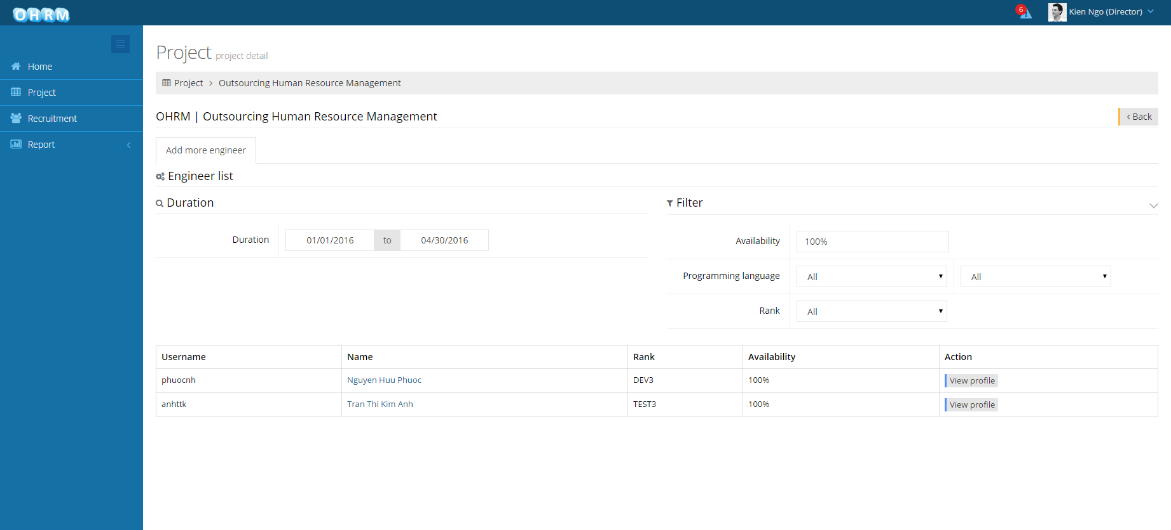

1. Suggest engineer

|  |  |  |  |  |  |  |  |
| --- | --- | --- | --- | --- | --- | --- | --- |
| No | Field name | Field name in Vietnamese | Type | Require | Mandatory | Max-Length | Description |
| 1 | Duration | Thời gian | Date |  | Y |  | Project’s Duration |
| 2 | Availability | Độ rảnh rổi | Text |  | Y |  | Project’s Availability |
| 3 | Programming language | Ngôn ngữ lập trình | Drop down list |  | Y |  | Project’s Programming language |
| 4 | Rank | Thứ hạng | Drop down list |  | Y |  | Project’s Rank |
| 5 | Suggest engineer list | Danh sách đươc gợi ý | List |  | Y |  | Suggest list |

1. Suggest engineer

### Assign engineer to project

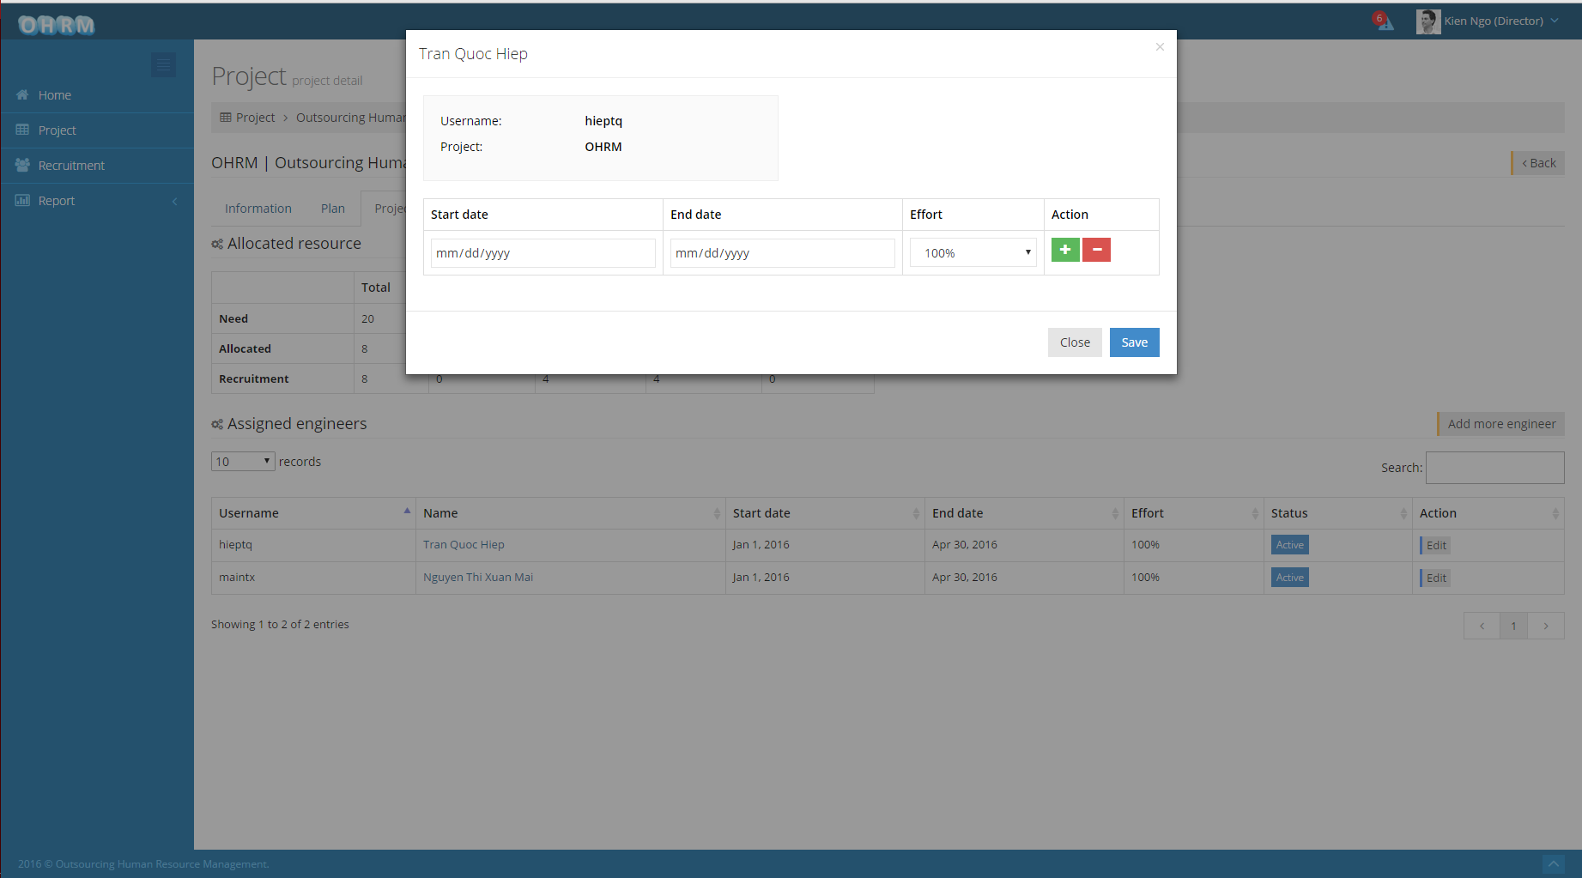

1. Assign engineer to project

|  |  |  |  |  |  |  |  |
| --- | --- | --- | --- | --- | --- | --- | --- |
| No | Field name | Field name in Vietnamese | Type | Require | Mandatory | Max-Length | Description |
| 1 | Start date | Ngày bắt đầu | Date |  | Y |  | Engineer’s Start date in project |
| 2 | End date | Ngày kết thúc | Date |  | Y |  | Engineer’s End date in project |
| 3 | Effort |  | Drop down list |  | Y |  | Engineer’s Effort in project |
| 4 | Plug sign | Dấu cộng | Button |  | Y |  | Plug assign |
| 5 | Minus sign | Dấu trừ | Button |  | Y |  | Minus assign |
| 6 | Save | Lưu | Button |  | Y |  | Save assign |
| 7 | Cancel | Hủy |  |  |  |  | Cancel assign |

1. Assign engineer to project

### Edit project member position



1. Edit project member postion

|  |  |  |  |  |  |  |  |
| --- | --- | --- | --- | --- | --- | --- | --- |
| No | Field name | Field name in Vietnamese | Type | Require | Mandatory | Max-Length | Description |
| 1 | Start date | Ngày bắt đầu | Date |  | Y |  | Engineer’s Start date in project |
| 2 | End date | Ngày kết thúc | Date |  | Y |  | Engineer’s End date in project |
| 3 | Effort |  | Drop down list |  | Y |  | Engineer’s Effort in project |
| 4 | Plug sign | Dấu cộng | Button |  | Y |  | Plug assign |
| 5 | Minus sign | Dấu trừ | Button |  | Y |  | Minus assign |
| 6 | Save | Lưu | Button |  | Y |  | Save assign |
| 7 | Cancel | Hủy |  |  |  |  | Cancel assign |

1. Edit project member position

## Recruitment

### Create recruitment

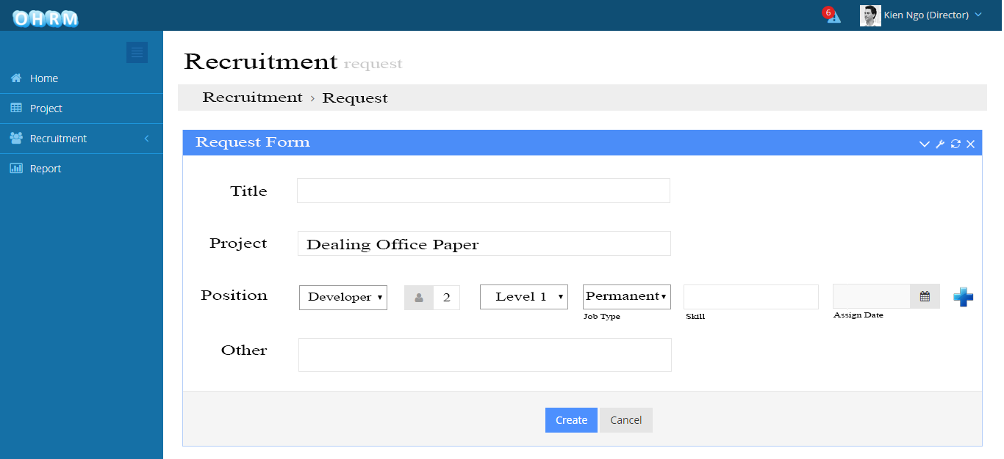

1. Information tab screen

|  |  |  |  |  |  |  |  |
| --- | --- | --- | --- | --- | --- | --- | --- |
| No | Field name | Field name in Vietnamese | Type | Require | Mandatory | Max-Length | Description |
| 1 | Title | Tiêu đề | Text |  | Y |  | Title of recruitment |
| 2 | Project | Dự án | Label |  | Y |  | Recruitment belongs to this project |
| 3 | Position | Vị trí | Drop down list |  | Y |  | Position of engineer |
| 4 | Number | Số lượng | text |  | Y |  | Number of engineer |
| 5 | Level | Cấp độ | Drop down list |  | Y |  | Level of engineer |
| 6 | Skill | Kỉ năng | Text |  | Y |  | Skill of engineer |
| 7 | Assign date | Ngày được đưa vào | Date |  | Y |  | Date that engineer assign to project |
| 8 | Plus sign | Dấu cộng | Butoon |  | Y |  | Add one more line |
| 9 | Other | Ý kiến khác | Text |  |  |  | Recruitment’s comment |
| 10 | Create | Tạo | Button |  | Y |  | Create recruitment |
| 11 | Cancel | Hủy bỏ | Button |  | Y |  | Cancel recruitment |

1. Create recruitment

### Search recruitment

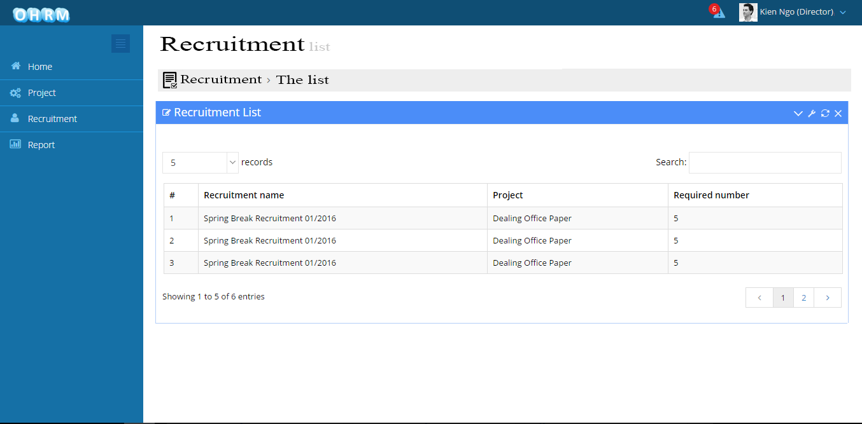

1. Search recruitment

|  |  |  |  |  |  |  |  |
| --- | --- | --- | --- | --- | --- | --- | --- |
| No | Field name | Field name in Vietnamese | Type | Require | Mandatory | Max-Length | Description |
| 1 | Search | Tìm kiếm | Text |  | Y |  | Search name of recruitment |

1. Search recruitment

### View recruitment detail

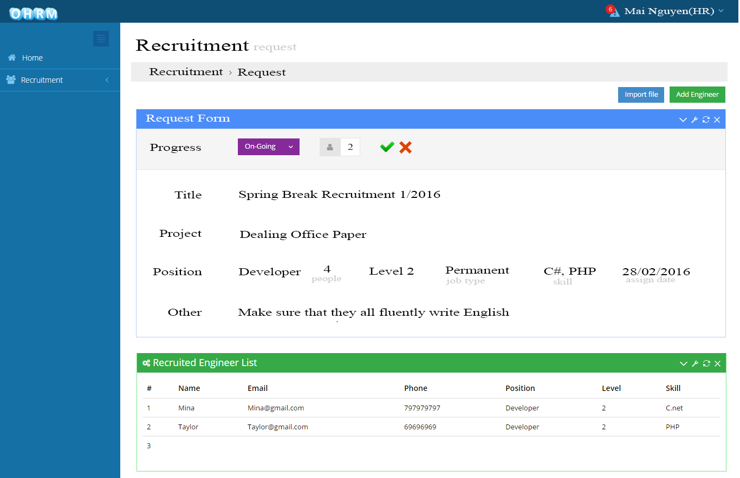

1. View recruitment detail

|  |  |  |  |  |  |  |  |
| --- | --- | --- | --- | --- | --- | --- | --- |
| No | Field name | Field name in Vietnamese | Type | Require | Mandatory | Max-Length | Description |
| 1 | Title | Tiêu đề | Label |  | Y |  | Title of recruitment |
| 2 | Project | Dự án | Label |  | Y |  | Recruitment belongs to this project |
| 3 | Position | Vị trí | Label |  | Y |  | Position of engineer |
| 4 | Number | Số lượng | Label |  | Y |  | Number of engineer |
| 5 | Level | Cấp độ | Label |  | Y |  | Level of engineer |
| 6 | Skill | Kỉ năng | Label |  | Y |  | Skill of engineer |
| 7 | Assign date | Ngày được đưa vào | Label |  | Y |  | Date that engineer assign to project |
| 8 | Other | Ý kiến khác | Label |  |  |  | Recruitment’s comment |
| 9 | Recruited engineer list | Danh sách những kỉ sư đã tuyển | List |  | Y |  | List of engineer for this recruitment |
| 10 | Import file | Nhập file | Button |  | Y |  | Upload list of recruited engineer |
| 11 | Add engineer | Thêm kỉ sư | Button |  | Y |  | Add list of recruited engineer |

1. View recruitment detail

### Edit recruitment

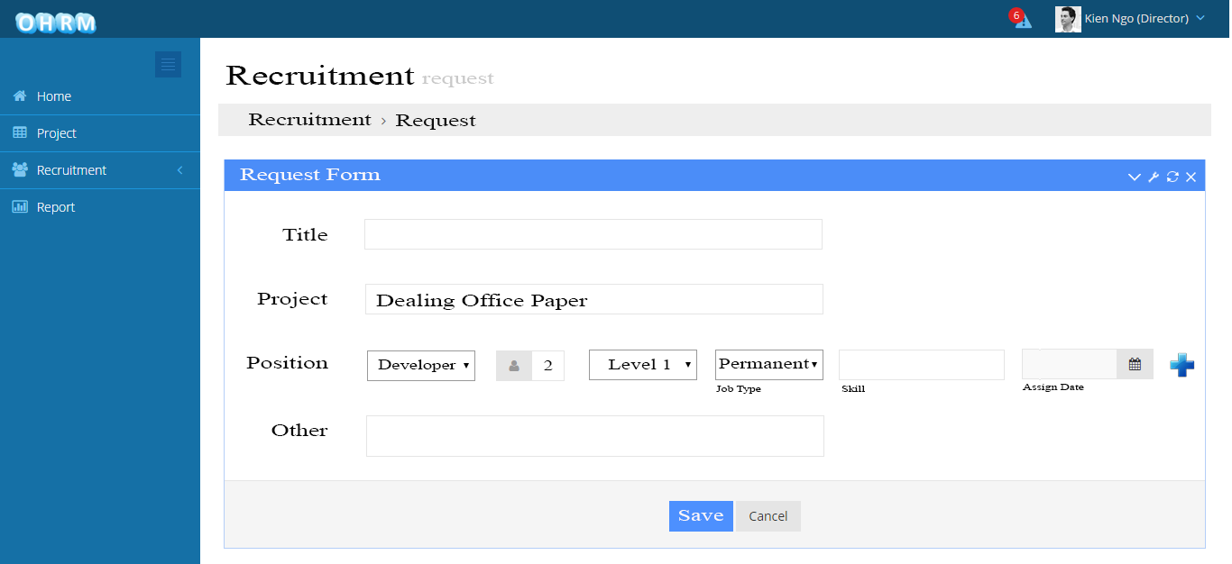

1. Edit recruitment

|  |  |  |  |  |  |  |  |
| --- | --- | --- | --- | --- | --- | --- | --- |
| No | Field name | Field name in Vietnamese | Type | Require | Mandatory | Max-Length | Description |
| 1 | Title | Tiêu đề | Text |  | Y |  | Title of recruitment |
| 2 | Project | Dự án | Label |  | Y |  | Recruitment belongs to this project |
| 3 | Position | Vị trí | Drop down list |  | Y |  | Position of engineer |
| 4 | Number | Số lượng | text |  | Y |  | Number of engineer |
| 5 | Level | Cấp độ | Drop down list |  | Y |  | Level of engineer |
| 6 | Skill | Kỉ năng | Text |  | Y |  | Skill of engineer |
| 7 | Assign date | Ngày được đưa vào | Date |  | Y |  | Date that engineer assign to project |
| 8 | Plus sign | Dấu cộng | Butoon |  | Y |  | Add one more line |
| 9 | Other | Ý kiến khác | Text |  |  |  | Recruitment’s comment |
| 10 | Save | Lưu | Button |  | Y |  | Save updated information |
| 11 | Cancel | Hủy bỏ | Button |  | Y |  | Cancel recruitment |

1. Edit recruitment

### Change recruitment status



1. Change recruitment status

|  |  |  |  |  |  |  |  |
| --- | --- | --- | --- | --- | --- | --- | --- |
| No | Field name | Field name in Vietnamese | Type | Require | Mandatory | Max-Length | Description |
| 1 | Progress | Tiến độ | Drop down list |  | Y |  | Progress of recruitment |
| 2 | Number | Số lượng | Text |  | Y |  | Number of recruited engineer |
| 3 | Plug sign | Dấu cộng | Button |  | Y |  | Save change |
| 4 | Cancel sign | Dấu x | Button |  | Y |  | Cancel change |

1. Change recruitment status

### Add engineer

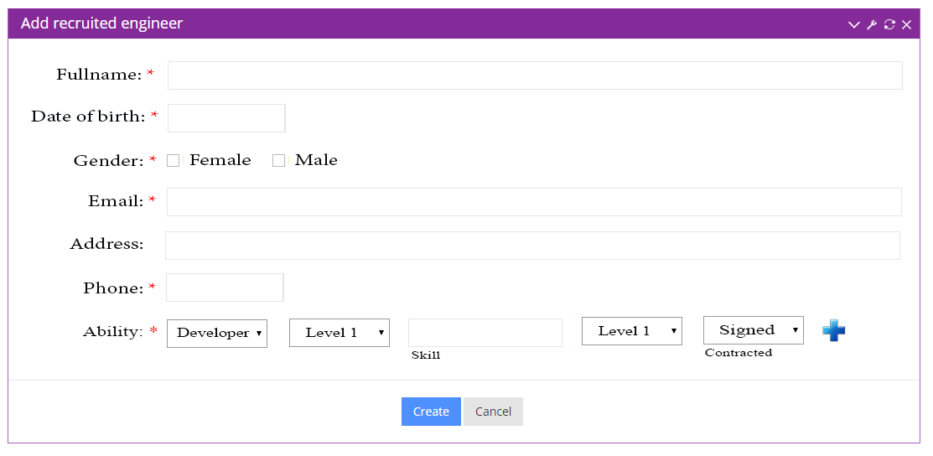

1. Add engineer

|  |  |  |  |  |  |  |  |
| --- | --- | --- | --- | --- | --- | --- | --- |
| No | Field name | Field name in Vietnamese | Type | Require | Mandatory | Max-Length | Description |
| 1 | Full name | Tên | Text |  | Y |  | Name of engineer |
| 2 | Date of birth | Ngày sinh | Date |  | Y |  | Birthday of engineer |
| 3 | Gender | Giới tính | Check box |  | Y |  | Gender of engineer |
| 4 | Email | Mail | Text |  | Y |  | Email of engineer |
| 5 | Address | Địa chỉ | Text |  | Y |  | Address of engineer |
| 6 | Phone | Điện thoại | Text |  | Y |  | Phone of engineer |
| 7 | Position | Vị trí | Drop down list |  | Y |  | Position of engineer |
| 8 | Level | Cấp độ | Drop down list |  | Y |  | Level of position |
| 9 | Skill | Kỉ năng | Text |  |  |  | Skill of engineer |
| 10 | Level | Cấp độ | Drop down list |  | Y |  | Level of skill |
| 11 | Contracted | Hợp đồng | Drop down list |  | Y |  | Type of contract |
| 12 | Create | Tạo | Button |  | Y |  | Add new engineer |
| 13 | Cancel | Hủy | Button |  | Y |  | Cancel |

1. Add engineer

### Import file

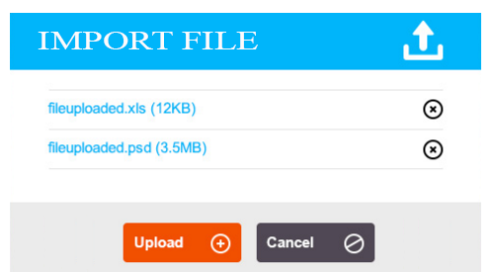

1. Import file

|  |  |  |  |  |  |  |  |
| --- | --- | --- | --- | --- | --- | --- | --- |
| No | Field name | Field name in Vietnamese | Type | Require | Mandatory | Max-Length | Description |
| 1 | Upload | Tải lên | Button |  | Y |  | Upload engineer list |

1. Import file

## Report

### Generate busy rate statistics

1. Back project screen

|  |  |  |  |  |  |  |  |
| --- | --- | --- | --- | --- | --- | --- | --- |
| No | Field name | Field name in Vietnamese | Type | Require | Mandatory | Max-Length | Description |
| 1 |  |  |  |  |  |  |  |
| 2 |  |  |  |  |  |  |  |
| 3 |  |  |  |  |  |  |  |
| 4 |  |  |  |  |  |  |  |
| 5 |  |  |  |  |  |  |  |
| 6 |  |  |  |  |  |  |  |

1. Back project

### Payment project

1. Payment project screen

|  |  |  |  |  |  |  |  |  |
| --- | --- | --- | --- | --- | --- | --- | --- | --- |
| No | | Field name | Field name in Vietnamese | Type | Require | Mandatory | Max-Length | Description |
| 1 |  | |  |  |  |  |  |  |
| 2 |  | |  |  |  |  |  |  |
| 3 |  | |  |  |  |  |  |  |
| 4 |  | |  |  |  |  |  |  |
| 5 |  | |  |  |  |  |  |  |
| 6 |  | |  |  |  |  |  |  |
| 7 |  | |  |  |  |  |  |  |

1. Payment project